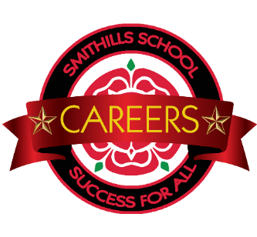
Careers Education Information Advice & Guidance
Events Calendar 2021-22
Date | Year | Activity/Event | Time
Thursday 7th October 2021 | Y10 | Year 10 Fight Hunger Create Change Social Impact Day | 9.30-1.00pm
Thursday 14th October 2021 | Y10 | Year 10 CEIAG Conference: How Employable Am I | All day
Wednesday 8th December 2021 | Y9 | Year 9 CEIAG Conference: On the right Track | All day
Wednesday 15th December 2021 | All Years | Stalls in the Hall ( Enterprise Challenge)
Friday 21st January 2022 | Y11 | Year 11 CEIAG Conference: Mock Interviews | All day
Tuesday 8th February 2022 | Y8 | Year 8 CEIAG Conference: Bright Futures | All day
Friday 11th February 2022 | Y11 | Admission Interview ( Morning) with  The Sixth Form Bolton ( Y11) | AM
Monday 28th March -Friday 1st April 2022 | Y10 | Work Experience Week 2022 | Full week
Friday 29th April 2022 | Y7 | Year 7 CEIAG Conference: Unleashing My Potential | All day
Wednesday 6th July 2022 | Y10 | Y10 Transition Day 2022 (The Sixth Form) | All day
Thursday 7th July 2022 | Y10 | Y10 Transition Day 2022 ( Bolton College) | All day
Date TBC | Year 8 | Star Student Board Game  ( University of Manchester) | One session each throughout the day
Date TBC | Year 9 | University Visit( Bolton University) | Half day
Date TBC | Year 11 | Y11 Gateways with University of Manchester  ( 12 Most able/ High achievers) | All day
Date TBC | Year 10 | Y10 Gateways with University of Manchester  ( 12 Most able/ High achievers) | All day
Date TBC | Year 9 | Y9 Gateways with University of Manchester  ( 12 Most able/ High achievers) | All day
Date TBC | Year 8 | Y8 Gateways with University of Manchester  ( 12 Most able/ High achievers) | All day
Date TBC | Year 7 | Y7 with University of Manchester  ( 12 Most able/ High achievers) | All day

This events calendar will be updated throughout the year

