

**WORK EXPERIENCE 2022-23**

**Monday 27th March - Friday 31st March 2023**

ted

**Information for Parents & Students**

[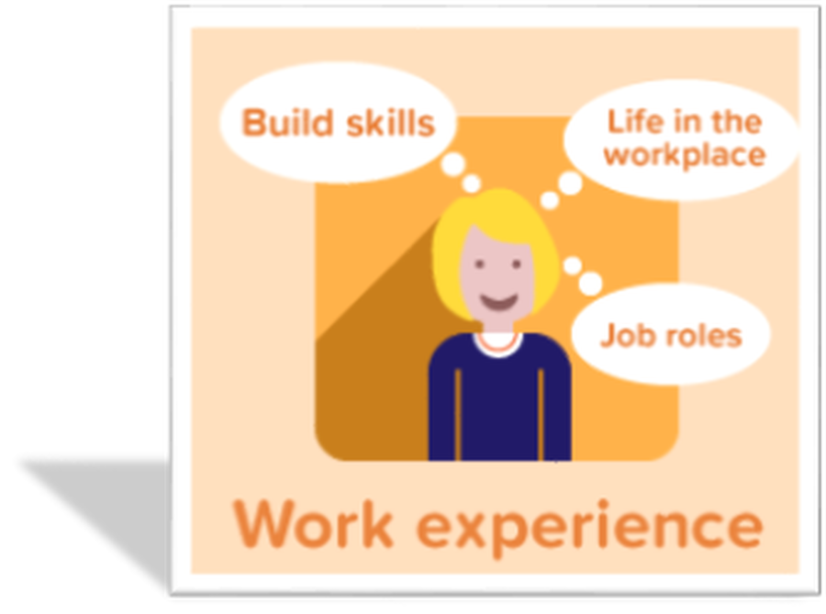](http://www.google.com/url?sa=i&rct=j&q=&esrc=s&source=images&cd=&ved=2ahUKEwjUn6HdiOTiAhV5AWMBHVbFAk8QjRx6BAgBEAU&url=http://www.kingswodehoe.essex.sch.uk/extra-curricular/work-experience&psig=AOvVaw0RfI47fognkV4ZU33Xn6YG&ust=1560433126316011)

**WHY should you take part in Work Experience?**

**[](https://www.google.com/url?sa=i&rct=j&q=&esrc=s&source=images&cd=&ved=2ahUKEwi9ifPziuTiAhVl5eAKHe4jCcsQjRx6BAgBEAU&url=https://www.stowuplandhighschool.co.uk/work-experience/&psig=AOvVaw0RfI47fognkV4ZU33Xn6YG&ust=1560433126316011)**

Most employers and universities are looking to recruit students with some experience of work. This may not be in the specific field for which they will eventually go into employment, however they do want students to have experienced a work place and the benefits that accompany that placement.

Not everyone will get to work with the company they would like to work with in the future. Some employers do not take students under 16 and some have limited places or are unable to accommodate students during the schools work experience dates. You will need to appreciate that every offer of a placement will provide a really valuable experience.

**WORK EXPERIENCE 2023**

This leaflet is intended to give you information that will help guide you and your child through the process of applying for a work experience placement*.*

**What is Work Experience?**

Work Experience is a valuable and rewarding learning experience, gained in a real working environment. It offers a taste of what ‘working life’ is all about and provides the opportunity to develop employability skills, increase self-esteem and develop greater independence.

[](https://www.google.com/url?sa=i&source=images&cd=&cad=rja&uact=8&ved=2ahUKEwj3xeWuh7rbAhXIaRQKHTBkA00QjRx6BAgBEAU&url=http://www.braidwood.bham.sch.uk/permalink/4278.html&psig=AOvVaw3cYb9cY4URTocO6Xa6HVlp&ust=1528202887377421)

**Please note that Pre 16 work experience is not always necessarily directly associated with a student’s long term career choice.**

Some career experiences are not available because of age or health and safety issues, e.g. medical placements for example or work involving heavy machinery. There are also some placements where confidentiality and sensitivity are paramount, working in social care for example. Students will usually have another opportunity to take part on a more specific career related work experience during their post 16 education.

Work experience lasts for one week andwill take place from **Monday 27th March - Friday 31st March 2023**

Placements follow a normal working week, not necessarily school hours,howeverany unusual arrangements should be checked through school, i.e. working shifts.

**Health & Safety**

It is **essential** that students secure placements which have been Health and Safety vetted as many will be under 16 years of age, and this affects insurance matters. Therefore we will only allow students to go on placements with employers who have **Employers Liability Insurance** in place and which have been Health & Safety checked for us by Tailored Education.

This year we will once again be working with Tailored Education who provide a large database of ‘potential’ placements across a wide range of different sectors. Students are given instructions on how to use the database during a year 10 assembly and will be given some opportunity to access the database during their Year 10 Conference. However please be aware that although the employers on the database do offer work experience opportunities, they DO NOT always offer them at the times that Smithills operates their programme, and do not offer placements to every school. Once they have filled their allocation for the year they will decline any further requests.

[](https://www.google.co.uk/imgres?imgurl=http://www.oltrefreepress.com/public/uploads/2011/07/Work-Exprerience.jpg&imgrefurl=http://lionresume.dvrlists.com/job-experience.html&docid=ikgZ4jHB5MlHoM&tbnid=V7PJWh65a4Tq1M:&w=500&h=500&safe=strict&bih=584&biw=997&ved=0ahUKEwjTm4_5p_3OAhXrD8AKHQAGBasQMwhKKCIwIg&iact=mrc&uact=8)

**Arranging a Work Experience Placement**

Following the Coronavirus pandemic and changes in work patterns for many people, we anticipate that it will become increasingly challenging to secure placements for all students this year. We would therefore encourage students to source their own placement as far as possible using family contacts, friends and professional networks. It may be possible for parents to organise a placement at their own place of work for their child.

**Sourcing your OWN PLACEMENT for 2023**

Students will be issued with a covering letter for the employer and a **‘Placement Employer Details Form’** that they will need the employer to complete. This should be returned promptly to enable the appropriate health & safety checks to take place. Please be aware that it is a lengthy process from start to finish to have a placement approved and involves; making contact with the employer; liaising with them to secure a suitable and relevant placement for the student; ensuring all the required Health & Safety procedures are in place prior to the start of the programme; and collating all necessary documentation from each student and parent. Therefore if your child already has a specific placement in mind, we need to start the process as soon as possible, to ensure they are able to complete their preferred choice of work placement. Following the completion of the Health and Safety check and the placement being approved, the student can then be confirmed on the placement and will receive a ‘**Student Contract’** which will require a signature from both student and parent before being returned to school.

Where it is not possible for students to source their own placements, they have access to the **Tailored Education** database and will be asked to submit a ‘**Request Placement Form’** to the CAREERS office so that the Work Experience administrator in school can support students in securing placements. This should be completed as soon as possible, to avoid disappointment.

<https://fls.work-experience.co.uk/Login>

Students should be encouraged to access the Tailored Education website independently using our School work experience login and password ( Login: Student 011 Password: Student01) and should discuss their choices with parents. All information will be available on the school careers website. There is a link available from the Careers (CEIAG) page of the school website and information on work experience on the student page.

**BEFORE a placement can be approved**

It is important that before submitting any request for Work Experience, students have researched the job, and should be confident that they have transport means to get to the placement should it be allocated to them. Students may need to use public transport during this week and therefore to make this cheaper, may need to purchase an IGO travel card if they do not already have one.

Parents will need to complete the work experience ‘**Medical Form’** This MUST be signed by a Parent\Carer and returned to CAREERS asap. It is very important we know about any medical conditions before being able to confirm a placement with the employer in order to keep your child safe in the work place.

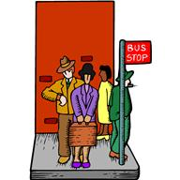Students are instructed to consider:

* **Am I happy to perform the tasks outlined on the job description?**
* **What time will the placement start and finish?**
* **Where is the placement located? Can I get there on time?**
* **What method of transport will I need to use to get there and back?**

**Primary schools:** Please note that from past experience, MOST schools ask former students NOT to apply for a placement at the primary school they previously attended or at a school where they have brothers or sisters currently attending. If you would like to apply to your former primary school you must make the school aware of this when applying to avoid disappointment later down the line.

**How can parents and carers help?**

* Discussing your child’s choice of placement and helping them to make an informed and realistic choice.
* Reading through the job description for the placement with them to make sure they understand the main tasks they will be undertaking.
* Ensuring that your child knows exactly how they are getting to and from their placement.
* Signing and returning to school any paperwork issued promptly.
* Reporting any sickness or absence immediately to the employer and to the school during the Work Experience Week.
* Reporting any concerns or worries regarding work experience to school.
* Providing any special equipment that might be needed for the placement e.g. safety boots (if not provided by the employer).

[](http://www.google.co.uk/url?sa=i&rct=j&q=&esrc=s&source=images&cd=&cad=rja&uact=8&ved=0ahUKEwjEqeqSrf3OAhUGVxoKHZSkALAQjRwIBw&url=http://www.freepik.com/free-photos-vectors/work&psig=AFQjCNG_6EXuFrFd8Y3jo9t3ri7OFi2pFA&ust=1473341000925402)

**Some facts about Work Experience**

* Employers receive no payment for accepting students – it is purely goodwill.
* School will monitor the progress of the students during the placement.
* The student will have a named contact at school.
* Employers agree to provide responsible adult supervision.
* Their instructions, particularly regarding health and safety, must be observed. Students will not be allowed to engage in any hazardous activity.
* At the end of the placement all employers are asked to complete an Employer’s Feedback Form where they report on a students’ performance over the week. Students should return this to school where we take a copy and then issue the original in their Record of Achievement folder together with their certificate for completion of the programme.
* All students who complete their work experience diary in full will receive a more detailed certificate demonstrating they have completed all aspects of the work experience programme successfully.

[](http://www.google.co.uk/url?sa=i&rct=j&q=&esrc=s&source=images&cd=&cad=rja&uact=8&ved=0ahUKEwj35YGQrv3OAhXDxRQKHUQJAgsQjRwIBw&url=http://www.freeimages.com/search/early-bird&psig=AFQjCNEZHxPtiD4oaVwQsRGJYmS3FUpgDQ&ust=1473341243326064)

**There will be a lot of competition for work experience placements so remember; The early bird really does catch the worm! Be proactive - don’t leave it until the last minute.**

**Please see Mrs Isaacs or Mrs John in the Careers Office for any help at all!**